CYCLONE DATASET

Description:

This Cyclone Dataset consists of the annual frequency of Cyclonic occurences [Cyclones, Cyclonic Disturbances, Severe cyclones] that occurred in the regions of Bay of Bengal, Arabian Sea and at Land during the years(1891-2021) in India.

Attributes:

Regions:

* BOB-BAY OF BENGAL
* AS- ARABIAN SEA
* LAND

Type of Cyclonic Occurrence:

* CYCLONIC DISTURBANCES -A Non-frontal synoptic scale low pressure area originating over tropical waters.
* CYCLONES
* SEVERE CYCLONES

OBJECTIVE:

To determine the type of cyclone which has the highest annual frequency and has the most number of occurrence in which region.

ds=read.csv("Annual Frequency of cyclones-1891-2021.csv")  
str(ds)

## 'data.frame': 131 obs. of 13 variables:  
## $ Year : int 1891 1892 1893 1894 1895 1896 1897 1898 1899 1900 ...  
## $ Cyclonic.Disturbances...BOB : int 9 8 10 8 10 9 9 9 7 10 ...  
## $ Cyclonic.Disturbances...AS : int 1 2 1 1 1 1 1 1 0 0 ...  
## $ Cyclonic.Disturbances...LAND : int 3 2 1 3 0 0 2 3 0 0 ...  
## $ Cyclonic.Disturbances...TOTAL: int 13 12 12 12 11 10 12 13 7 10 ...  
## $ Cyclones...BOB : int 2 5 9 5 4 7 5 6 3 3 ...  
## $ Cyclones...AS : int 1 1 1 1 1 1 1 1 0 0 ...  
## $ Cyclones...LAND : int 1 0 0 0 0 0 0 0 0 0 ...  
## $ Cyclones...TOTAL : int 4 6 10 6 5 8 6 7 3 3 ...  
## $ Severe.Cyclones...BOB : int 1 1 3 0 4 3 2 2 0 1 ...  
## $ Severe.Cyclones...AS : int 1 1 1 0 0 0 0 1 0 0 ...  
## $ Severe.Cyclones...LAND : int 1 0 0 0 0 0 0 0 0 0 ...  
## $ Severe.Cyclones...TOTAL : int 3 2 4 0 4 3 2 3 0 1 ...

summary(ds)

## Year Cyclonic.Disturbances...BOB Cyclonic.Disturbances...AS  
## Min. :1891 Min. : 3.000 Min. :0.000   
## 1st Qu.:1924 1st Qu.: 7.000 1st Qu.:1.000   
## Median :1956 Median : 9.000 Median :1.000   
## Mean :1956 Mean : 9.374 Mean :1.817   
## 3rd Qu.:1988 3rd Qu.:12.000 3rd Qu.:3.000   
## Max. :2021 Max. :16.000 Max. :8.000   
## Cyclonic.Disturbances...LAND Cyclonic.Disturbances...TOTAL Cyclones...BOB   
## Min. :0.000 Min. : 5.00 Min. :0.000   
## 1st Qu.:0.000 1st Qu.: 9.50 1st Qu.:3.000   
## Median :1.000 Median :12.00 Median :4.000   
## Mean :1.076 Mean :12.27 Mean :4.015   
## 3rd Qu.:2.000 3rd Qu.:15.00 3rd Qu.:5.000   
## Max. :4.000 Max. :20.00 Max. :9.000   
## Cyclones...AS Cyclones...LAND Cyclones...TOTAL Severe.Cyclones...BOB  
## Min. :0.000 Min. :0.0000 Min. : 1.00 Min. :0.000   
## 1st Qu.:0.000 1st Qu.:0.0000 1st Qu.: 4.00 1st Qu.:1.000   
## Median :1.000 Median :0.0000 Median : 5.00 Median :2.000   
## Mean :1.038 Mean :0.1069 Mean : 5.16 Mean :1.809   
## 3rd Qu.:2.000 3rd Qu.:0.0000 3rd Qu.: 6.00 3rd Qu.:3.000   
## Max. :5.000 Max. :2.0000 Max. :10.00 Max. :6.000   
## Severe.Cyclones...AS Severe.Cyclones...LAND Severe.Cyclones...TOTAL  
## Min. :0.0000 Min. :0.00000 Min. :0.000   
## 1st Qu.:0.0000 1st Qu.:0.00000 1st Qu.:1.000   
## Median :0.0000 Median :0.00000 Median :2.000   
## Mean :0.6412 Mean :0.03053 Mean :2.481   
## 3rd Qu.:1.0000 3rd Qu.:0.00000 3rd Qu.:4.000   
## Max. :5.0000 Max. :1.00000 Max. :7.000

head(ds)

## Year Cyclonic.Disturbances...BOB Cyclonic.Disturbances...AS  
## 1 1891 9 1  
## 2 1892 8 2  
## 3 1893 10 1  
## 4 1894 8 1  
## 5 1895 10 1  
## 6 1896 9 1  
## Cyclonic.Disturbances...LAND Cyclonic.Disturbances...TOTAL Cyclones...BOB  
## 1 3 13 2  
## 2 2 12 5  
## 3 1 12 9  
## 4 3 12 5  
## 5 0 11 4  
## 6 0 10 7  
## Cyclones...AS Cyclones...LAND Cyclones...TOTAL Severe.Cyclones...BOB  
## 1 1 1 4 1  
## 2 1 0 6 1  
## 3 1 0 10 3  
## 4 1 0 6 0  
## 5 1 0 5 4  
## 6 1 0 8 3  
## Severe.Cyclones...AS Severe.Cyclones...LAND Severe.Cyclones...TOTAL  
## 1 1 1 3  
## 2 1 0 2  
## 3 1 0 4  
## 4 0 0 0  
## 5 0 0 4  
## 6 0 0 3

tail(ds)

## Year Cyclonic.Disturbances...BOB Cyclonic.Disturbances...AS  
## 126 2016 6 2  
## 127 2017 8 0  
## 128 2018 9 4  
## 129 2019 4 8  
## 130 2020 5 4  
## 131 2021 7 3  
## Cyclonic.Disturbances...LAND Cyclonic.Disturbances...TOTAL Cyclones...BOB  
## 126 2 10 4  
## 127 2 10 3  
## 128 1 14 4  
## 129 0 12 3  
## 130 0 9 3  
## 131 0 10 3  
## Cyclones...AS Cyclones...LAND Cyclones...TOTAL Severe.Cyclones...BOB  
## 126 0 0 4 1  
## 127 0 0 3 2  
## 128 3 0 7 3  
## 129 5 0 8 2  
## 130 2 0 5 2  
## 131 2 0 5 1  
## Severe.Cyclones...AS Severe.Cyclones...LAND Severe.Cyclones...TOTAL  
## 126 0 0 1  
## 127 0 0 2  
## 128 3 0 6  
## 129 5 0 7  
## 130 2 0 4  
## 131 2 0 3

library(lattice)  
library(dplyr)

##   
## Attaching package: 'dplyr'

## The following objects are masked from 'package:stats':  
##   
## filter, lag

## The following objects are masked from 'package:base':  
##   
## intersect, setdiff, setequal, union

#Histograms and Boxplots  
histogram(~Cyclones...TOTAL,data=ds,breaks=50)

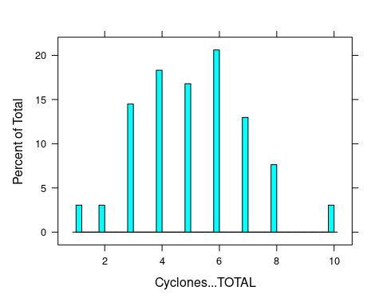

histogram(~Cyclonic.Disturbances...TOTAL,data=ds,breaks = 50)

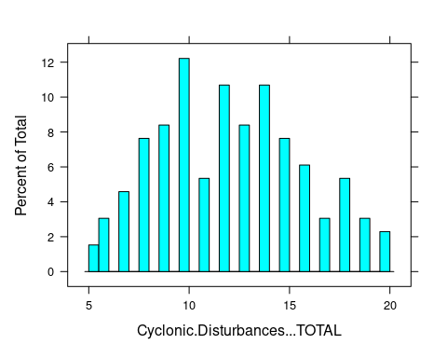

histogram(~Severe.Cyclones...TOTAL,data=ds,breaks = 50)

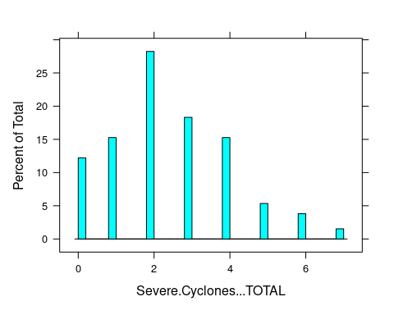

s1=mutate(ds,BOB=Cyclonic.Disturbances...BOB + Cyclones...BOB+Severe.Cyclones...BOB )  
summary(s1)

## Year Cyclonic.Disturbances...BOB Cyclonic.Disturbances...AS  
## Min. :1891 Min. : 3.000 Min. :0.000   
## 1st Qu.:1924 1st Qu.: 7.000 1st Qu.:1.000   
## Median :1956 Median : 9.000 Median :1.000   
## Mean :1956 Mean : 9.374 Mean :1.817   
## 3rd Qu.:1988 3rd Qu.:12.000 3rd Qu.:3.000   
## Max. :2021 Max. :16.000 Max. :8.000   
## Cyclonic.Disturbances...LAND Cyclonic.Disturbances...TOTAL Cyclones...BOB   
## Min. :0.000 Min. : 5.00 Min. :0.000   
## 1st Qu.:0.000 1st Qu.: 9.50 1st Qu.:3.000   
## Median :1.000 Median :12.00 Median :4.000   
## Mean :1.076 Mean :12.27 Mean :4.015   
## 3rd Qu.:2.000 3rd Qu.:15.00 3rd Qu.:5.000   
## Max. :4.000 Max. :20.00 Max. :9.000   
## Cyclones...AS Cyclones...LAND Cyclones...TOTAL Severe.Cyclones...BOB  
## Min. :0.000 Min. :0.0000 Min. : 1.00 Min. :0.000   
## 1st Qu.:0.000 1st Qu.:0.0000 1st Qu.: 4.00 1st Qu.:1.000   
## Median :1.000 Median :0.0000 Median : 5.00 Median :2.000   
## Mean :1.038 Mean :0.1069 Mean : 5.16 Mean :1.809   
## 3rd Qu.:2.000 3rd Qu.:0.0000 3rd Qu.: 6.00 3rd Qu.:3.000   
## Max. :5.000 Max. :2.0000 Max. :10.00 Max. :6.000   
## Severe.Cyclones...AS Severe.Cyclones...LAND Severe.Cyclones...TOTAL  
## Min. :0.0000 Min. :0.00000 Min. :0.000   
## 1st Qu.:0.0000 1st Qu.:0.00000 1st Qu.:1.000   
## Median :0.0000 Median :0.00000 Median :2.000   
## Mean :0.6412 Mean :0.03053 Mean :2.481   
## 3rd Qu.:1.0000 3rd Qu.:0.00000 3rd Qu.:4.000   
## Max. :5.0000 Max. :1.00000 Max. :7.000   
## BOB   
## Min. : 4.0   
## 1st Qu.:12.0   
## Median :15.0   
## Mean :15.2   
## 3rd Qu.:19.0   
## Max. :29.0

histogram(~BOB,data=s1,main="Cyclonic occurences at Bay of Bengal",breaks = 50)

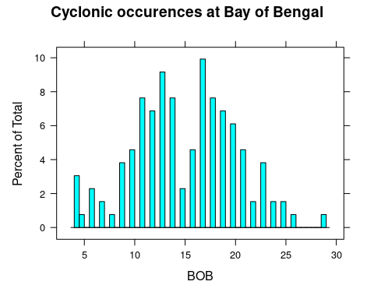

bwplot(BOB ~ Year, data = s1,main="Cyclonic occurences at Bay of Bengal ",  
 xlab="Year",ylab = "No. of occurences",col="yellow")

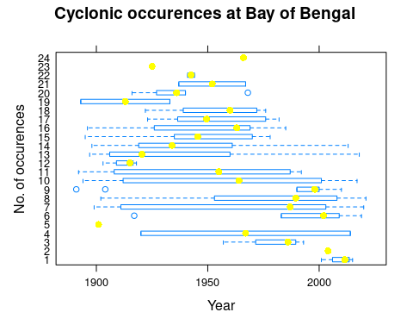

s2=mutate(ds,AS=Cyclonic.Disturbances...AS+Cyclones...AS+Severe.Cyclones...AS)  
summary(s2)

## Year Cyclonic.Disturbances...BOB Cyclonic.Disturbances...AS  
## Min. :1891 Min. : 3.000 Min. :0.000   
## 1st Qu.:1924 1st Qu.: 7.000 1st Qu.:1.000   
## Median :1956 Median : 9.000 Median :1.000   
## Mean :1956 Mean : 9.374 Mean :1.817   
## 3rd Qu.:1988 3rd Qu.:12.000 3rd Qu.:3.000   
## Max. :2021 Max. :16.000 Max. :8.000   
## Cyclonic.Disturbances...LAND Cyclonic.Disturbances...TOTAL Cyclones...BOB   
## Min. :0.000 Min. : 5.00 Min. :0.000   
## 1st Qu.:0.000 1st Qu.: 9.50 1st Qu.:3.000   
## Median :1.000 Median :12.00 Median :4.000   
## Mean :1.076 Mean :12.27 Mean :4.015   
## 3rd Qu.:2.000 3rd Qu.:15.00 3rd Qu.:5.000   
## Max. :4.000 Max. :20.00 Max. :9.000   
## Cyclones...AS Cyclones...LAND Cyclones...TOTAL Severe.Cyclones...BOB  
## Min. :0.000 Min. :0.0000 Min. : 1.00 Min. :0.000   
## 1st Qu.:0.000 1st Qu.:0.0000 1st Qu.: 4.00 1st Qu.:1.000   
## Median :1.000 Median :0.0000 Median : 5.00 Median :2.000   
## Mean :1.038 Mean :0.1069 Mean : 5.16 Mean :1.809   
## 3rd Qu.:2.000 3rd Qu.:0.0000 3rd Qu.: 6.00 3rd Qu.:3.000   
## Max. :5.000 Max. :2.0000 Max. :10.00 Max. :6.000   
## Severe.Cyclones...AS Severe.Cyclones...LAND Severe.Cyclones...TOTAL  
## Min. :0.0000 Min. :0.00000 Min. :0.000   
## 1st Qu.:0.0000 1st Qu.:0.00000 1st Qu.:1.000   
## Median :0.0000 Median :0.00000 Median :2.000   
## Mean :0.6412 Mean :0.03053 Mean :2.481   
## 3rd Qu.:1.0000 3rd Qu.:0.00000 3rd Qu.:4.000   
## Max. :5.0000 Max. :1.00000 Max. :7.000   
## AS   
## Min. : 0.000   
## 1st Qu.: 1.000   
## Median : 3.000   
## Mean : 3.496   
## 3rd Qu.: 6.000   
## Max. :18.000

histogram(~AS,data=s2,main="Cyclonic occurences at Arabian Sea",breaks=50)

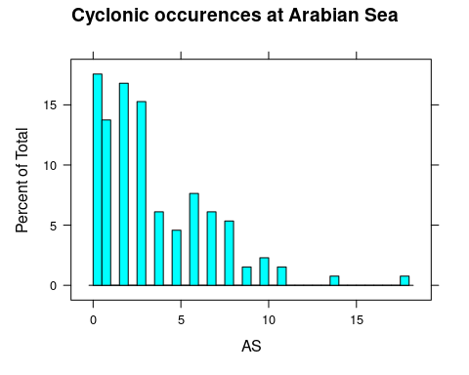

bwplot(AS ~ Year,data=s2,main="Cyclonic occurences at Arabian sea",  
 xlab="Year",ylab="No. of occurences",col="green")

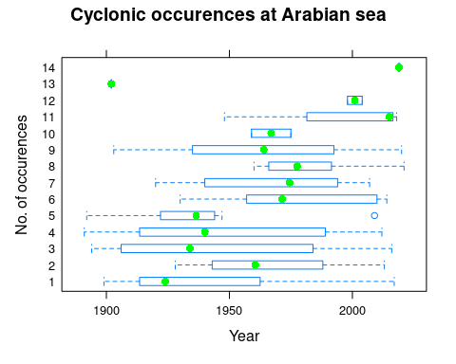

s3=mutate(ds,LAND=Cyclonic.Disturbances...LAND+Cyclones...LAND +Severe.Cyclones...LAND )  
summary(s3)

## Year Cyclonic.Disturbances...BOB Cyclonic.Disturbances...AS  
## Min. :1891 Min. : 3.000 Min. :0.000   
## 1st Qu.:1924 1st Qu.: 7.000 1st Qu.:1.000   
## Median :1956 Median : 9.000 Median :1.000   
## Mean :1956 Mean : 9.374 Mean :1.817   
## 3rd Qu.:1988 3rd Qu.:12.000 3rd Qu.:3.000   
## Max. :2021 Max. :16.000 Max. :8.000   
## Cyclonic.Disturbances...LAND Cyclonic.Disturbances...TOTAL Cyclones...BOB   
## Min. :0.000 Min. : 5.00 Min. :0.000   
## 1st Qu.:0.000 1st Qu.: 9.50 1st Qu.:3.000   
## Median :1.000 Median :12.00 Median :4.000   
## Mean :1.076 Mean :12.27 Mean :4.015   
## 3rd Qu.:2.000 3rd Qu.:15.00 3rd Qu.:5.000   
## Max. :4.000 Max. :20.00 Max. :9.000   
## Cyclones...AS Cyclones...LAND Cyclones...TOTAL Severe.Cyclones...BOB  
## Min. :0.000 Min. :0.0000 Min. : 1.00 Min. :0.000   
## 1st Qu.:0.000 1st Qu.:0.0000 1st Qu.: 4.00 1st Qu.:1.000   
## Median :1.000 Median :0.0000 Median : 5.00 Median :2.000   
## Mean :1.038 Mean :0.1069 Mean : 5.16 Mean :1.809   
## 3rd Qu.:2.000 3rd Qu.:0.0000 3rd Qu.: 6.00 3rd Qu.:3.000   
## Max. :5.000 Max. :2.0000 Max. :10.00 Max. :6.000   
## Severe.Cyclones...AS Severe.Cyclones...LAND Severe.Cyclones...TOTAL  
## Min. :0.0000 Min. :0.00000 Min. :0.000   
## 1st Qu.:0.0000 1st Qu.:0.00000 1st Qu.:1.000   
## Median :0.0000 Median :0.00000 Median :2.000   
## Mean :0.6412 Mean :0.03053 Mean :2.481   
## 3rd Qu.:1.0000 3rd Qu.:0.00000 3rd Qu.:4.000   
## Max. :5.0000 Max. :1.00000 Max. :7.000   
## LAND   
## Min. :0.000   
## 1st Qu.:0.000   
## Median :1.000   
## Mean :1.214   
## 3rd Qu.:2.000   
## Max. :6.000

histogram(~LAND,data=s3,main="Cyclonic occurences at land",breaks=50)

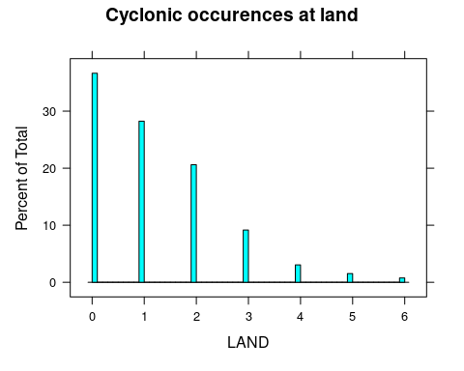

bwplot(LAND~Year,data=s3,main="Cyclonic occurences at land ",  
 xlab="Year",ylab="No.of Occurences",col="brown")

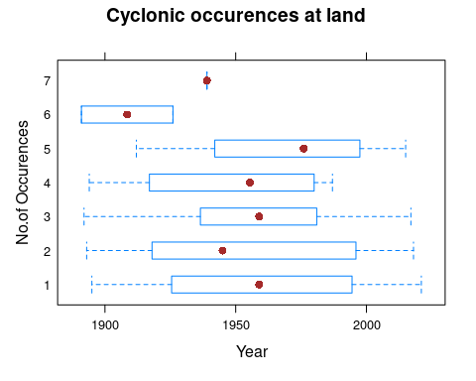

bwplot(BOB|Cyclonic.Disturbances...TOTAL~Year,data = s1,xlab = "Year",  
 ylab="Cyclonic disturbances at Bay of Bengal",col="red",main="Cyclonic  
 Disturbances at Bay of Bengal over years")

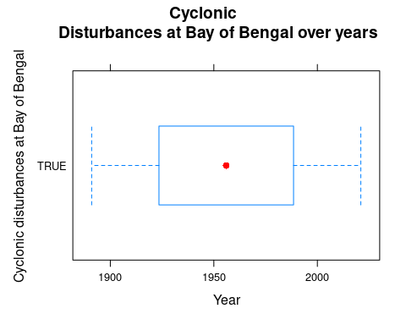

#Scatter plots  
s4 <- ds[,c("Year","Cyclonic.Disturbances...TOTAL")]  
plot(x= s4$Year, y= s4$Cyclonic.Disturbances...TOTAL,  
 xlab = "Year",  
 ylab= "Cyclonic Disturbances",  
 xlim= c(1891,2021),  
 ylim= c(4,20),  
 main= "Cyclonic disturbances over years")

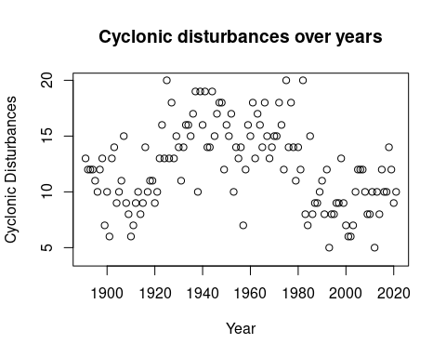

s5 <- s1[,c("BOB","Cyclonic.Disturbances...TOTAL")]  
plot(x=s5$BOB,y=s5$Cyclonic.Disturbances...TOTAL,  
 xlab="BOB",  
 ylab="Cyclonic Disturbances",  
 xlim=c(4,30),  
 ylim=c(4,20),  
 main="Cyclonic disturbances over Bay of Bengal")

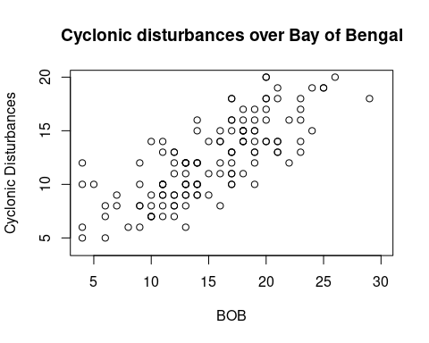

Histogram Analysis:

(For the Type of Cyclones)

* In the total number of cyclones occurred, the distribution is almost left skewed .The most number of occurences is 6 and the median value is 5.
* For the total number of cyclonic disturbances occurred, the distribution is right skewed. The most number of occurences is 10 and median value of the total cyclonic disturbances is 12.
* In the total number of Severe cyclones occurred, the distribution is almost right skewed. The most number of occurences is 2 and the median value is 3.

(For the Region of occurences)

* For the Bay of Bengal region, the distribution is almost left skewed. The most number of occurences is 17 and the median value is 15.
* For the Arabian Sea region, the distribution is right skewed. The most number of occurences is 0 and the median value is 3.
* In the land region, the distribution is right skewed. The most number of occurences is 0 and the median value is 1.

Hypothesis:

With the histogram analysis, we can have the following hypothesis:

* Cyclonic Disturbances have the most frequent occurences annually (in a year).
* Most of the cyclonic occurences are in the Bay of Bengal region annually.
* Therefore, there are high chances that the Bay of Bengal region witnesses more number of Cyclonic Disturbances in a year.

Box plot:

With the help of box plot between Total number of Cyclonic Disturbances at the Bay of Bengal over years, we can get to know that most of the values (above 60 percent) are covered in the range.

Scatter plot:

From the Scatter plot, we can come to the conclusion that

* There is no particular correlation between the Cyclonic disturbances and year.
* But, there is a positive correlation between the Cyclonic Disturbances and the Bay of Bengal (BOB) region.

**INFERENCES:**

From our analysis, we have the following Inferences

* From the three types of cyclones, Cyclonic Disturbances has occurred for the most number of times from 1891-2021.
* The Bay of Bengal region constitutes the most number of cyclonic occurences in the years.
* Severe cyclones has the least number of occurences over the years. It

Occurs rarely.

* The Land region has only least chances of Cyclonic occurences.

**INSIGHTS:**

Based on our inferences on the dataset, we could get the following insights

* The Annual frequency of Cyclonic disturbances are higher in the Bay of Bengal region.
* The Cyclonic disturbances have occurred the most number of times (20) during the year 1960-2000.
* Whenever the Bay of Bengal region has recorded the higher number of cyclonic occurences in a year, Cyclonic disturbances have a major part in it when compared to the other two types of cyclones.